|  |
| --- |
| EPAM Systems, RD Dep. |
| MTN.BI.07 Partitioning Report |

|  |  |  |  |  |  |
| --- | --- | --- | --- | --- | --- |
| REVISION HISTORY | | | | | |
| Ver. | Description of Change | Author | Date | Approved | |
| Name | Effective Date |
| 1.0 | Initial status | Hanna Hul | 13-NOV-2017 |  |  |

Contents

1. Hands-On Task 3

2. Data Modeling Task 3

3. Analytical task 3

3.1. Partitioning 3

3.2. Business 3

4. Results 3

# Hands-On Task

Create any table with some kind of partitioning to show next concepts:

* Adding Partition.

CREATE

TABLE range_example

(

date_id VARCHAR2(10),

range_key_column DATE NOT NULL,

MONTH VARCHAR2(20),

YEAR NUMBER,

day_of_month NUMBER

)

PARTITION BY RANGE

( range_key_column )

(

PARTITION part_1 VALUES LESS THAN ( TO_DATE('01/01/2018','dd/mm/yyyy') ),

PARTITION part_2 VALUES LESS THAN ( TO_DATE('01/01/2019','dd/mm/yyyy') ),

PARTITION part_3 VALUES LESS THAN ( MAXVALUE )

);

INSERT

INTO

range_example

(

date_id,

range_key_column,

MONTH ,

YEAR ,

day_of_month

)

SELECT

TO_CHAR(CurrDate,'YYYYMMDD'),

CurrDate,

TO_CHAR(CurrDate,'Month') AS Month_Long,

TO_CHAR(CurrDate,'YYYY') AS Year_ID,

TO_NUMBER(TRIM(leading '0'

FROM

TO_CHAR(CurrDate,'DD'))) AS Day_Num_of_Month

FROM

(

SELECT

level n,

TO_DATE('31/12/2016','DD/MM/YYYY') + NUMTODSINTERVAL(level,'day')

CurrDate

FROM

dual

CONNECT BY level <= 9000

)

ORDER BY

CurrDate;

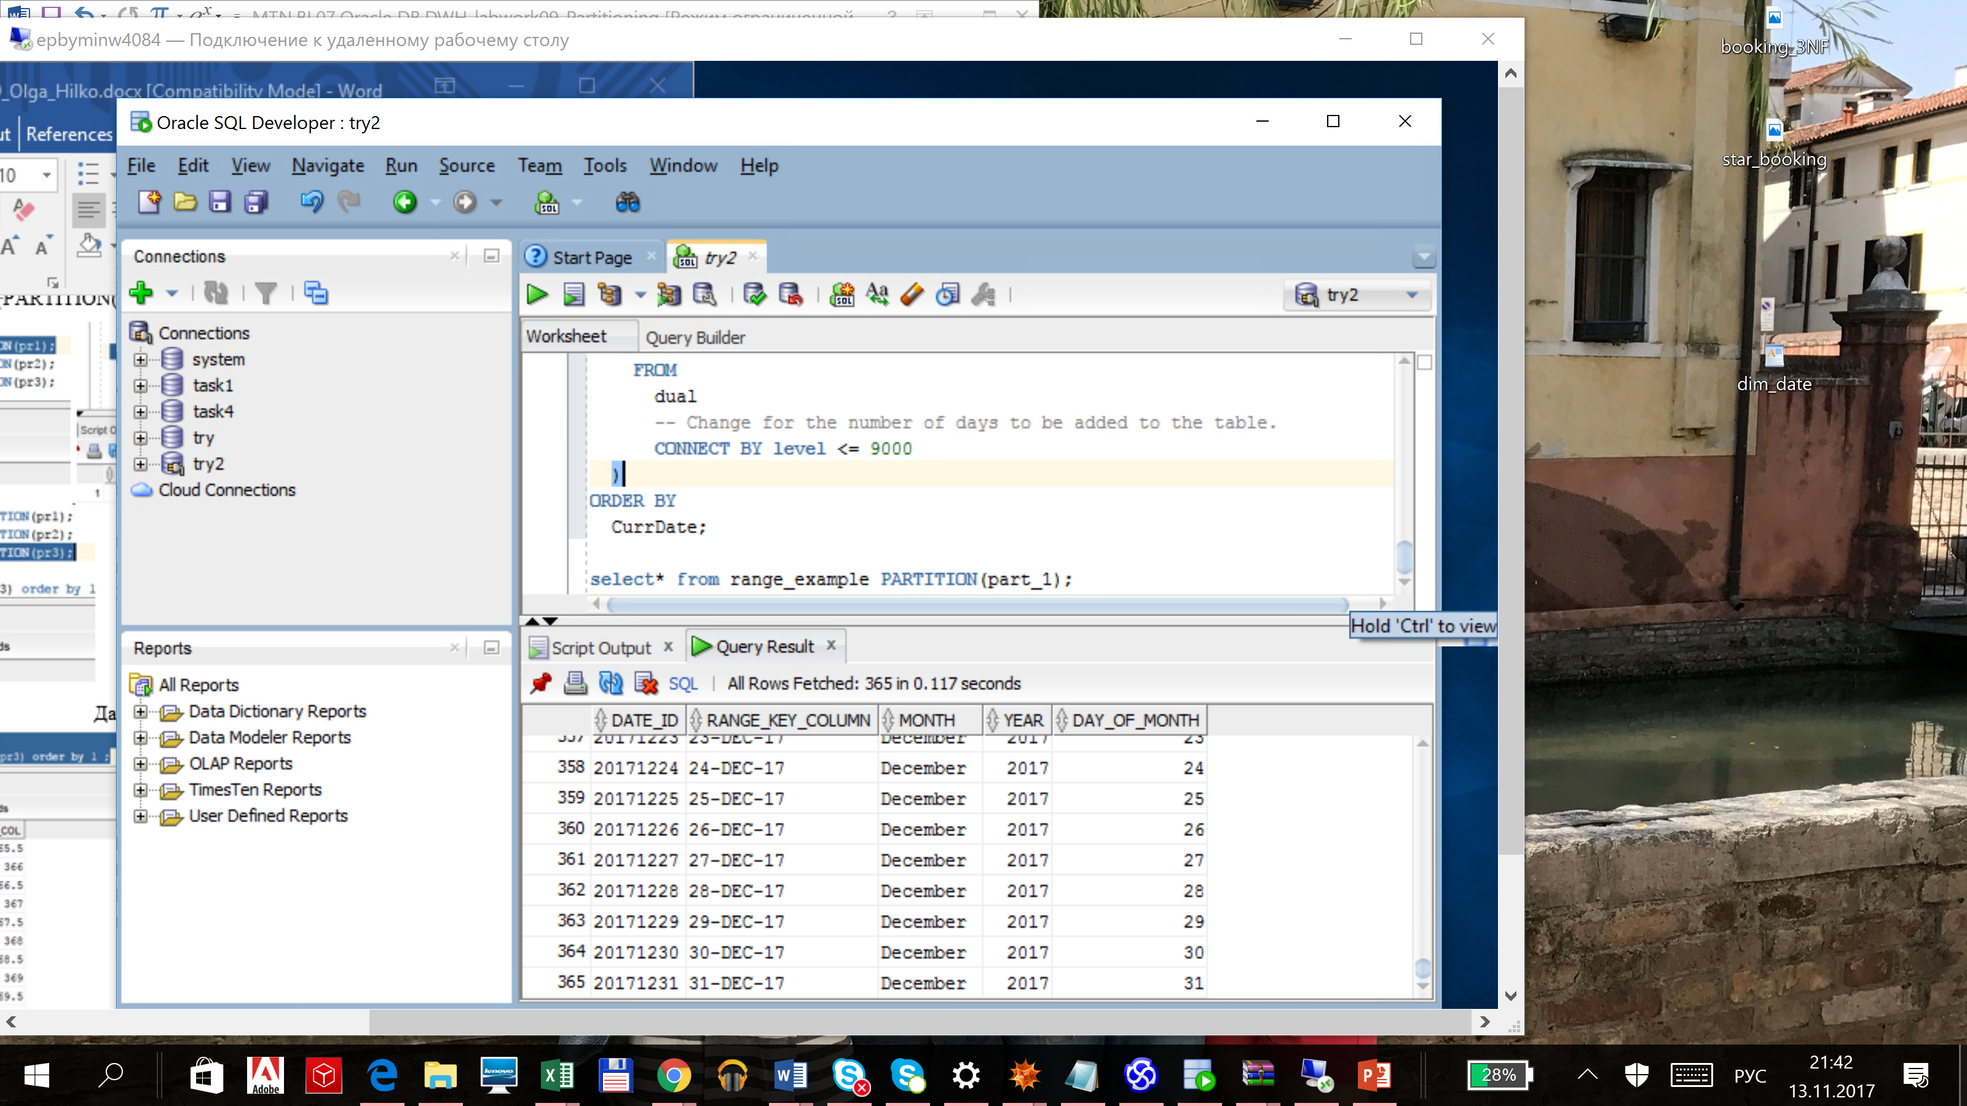**CHECKING**:

* Dropping Partition.

ALTER TABLE range_example DROP PARTITION part_1;

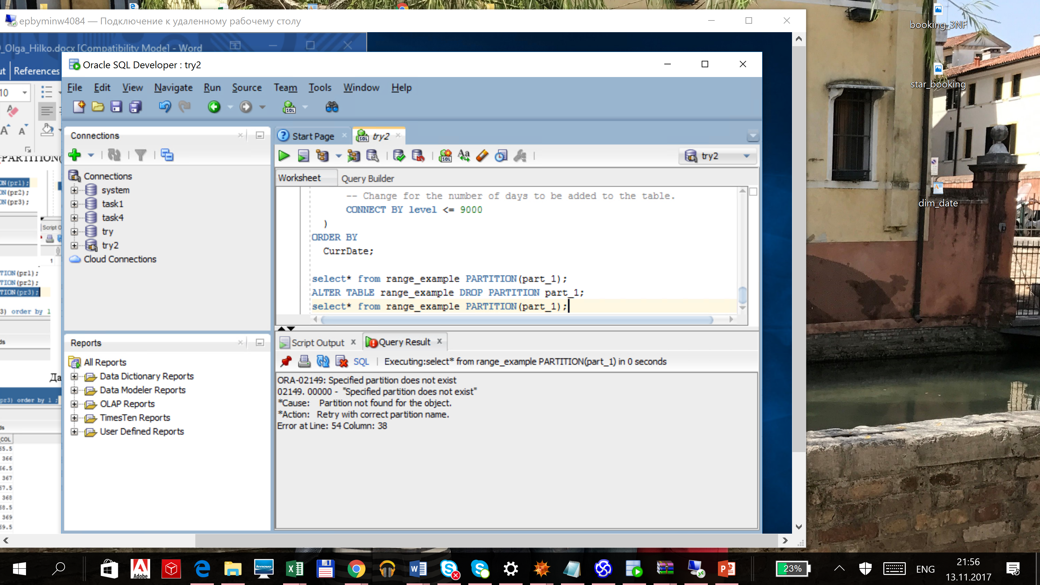

* Merging Partition.

ALTER TABLE range_example

MERGE PARTITIONS part_2, part_3 INTO PARTITION part_3

UPDATE INDEXES;

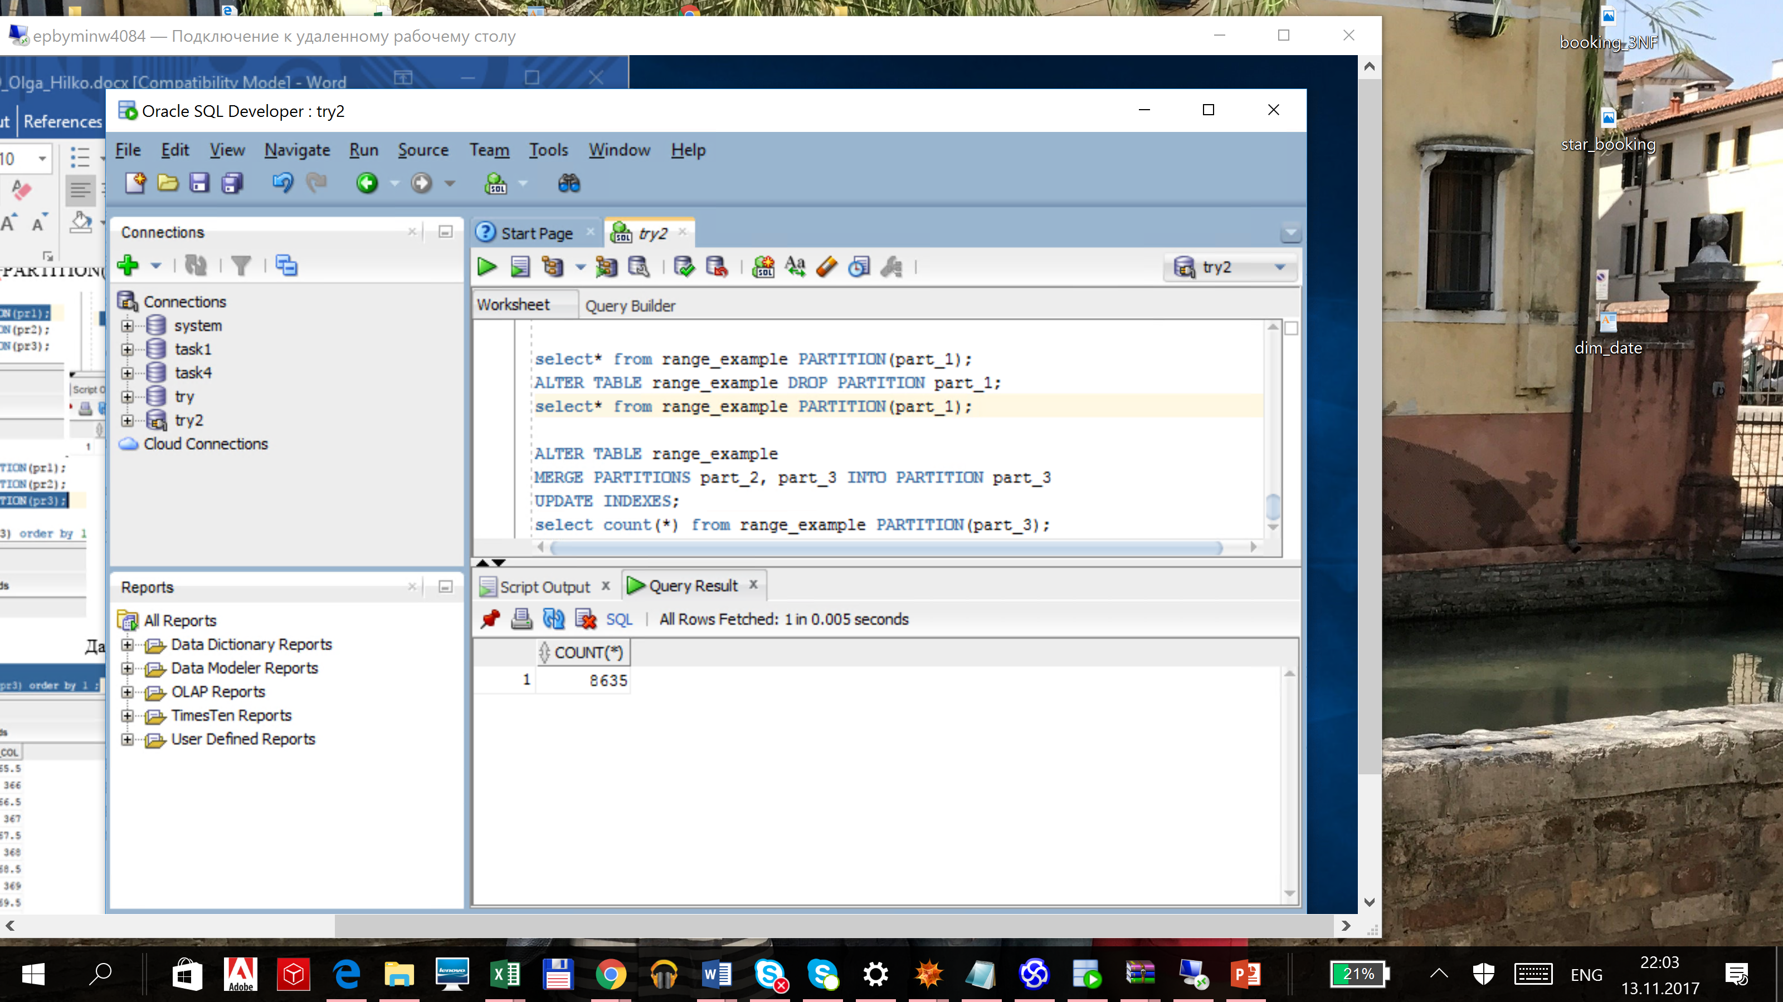

8365 rows as expected. The initial amount was 9000, then 365 rows were deleted and the other were merged into one partition.

* Splitting Partition.

ALTER TABLE range_example SPLIT PARTITION

part_3 at (TO_DATE('31/12/2019','DD/MM/YYYY')) INTO ( PARTITION

new_part_1, PARTITION new_part_2);

The last date of part_1 is '30/12/2019' as expected. It is performed on the screen below.

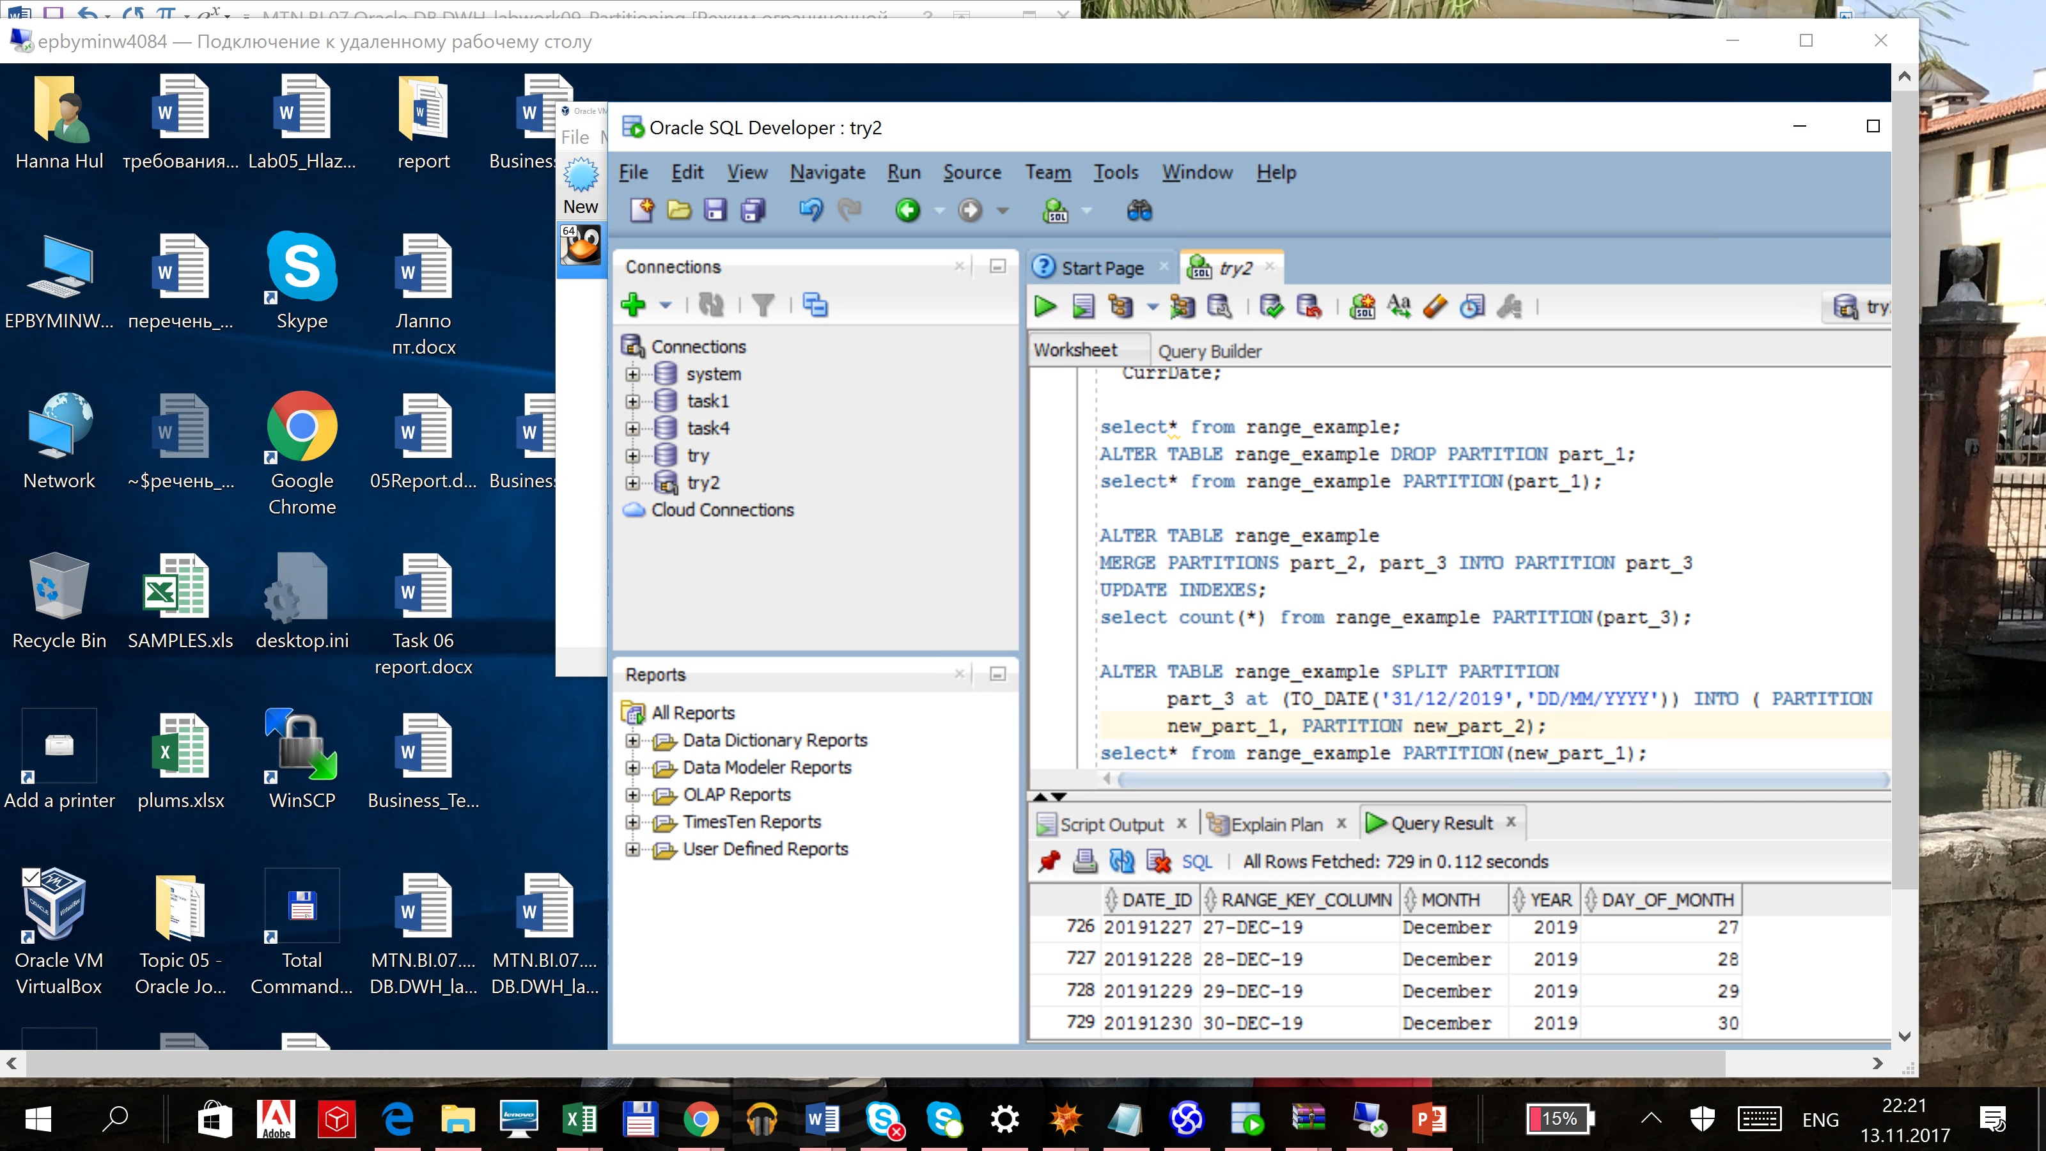

* Truncating Partition.

ALTER TABLE range_example TRUNCATE PARTITION new_part_1;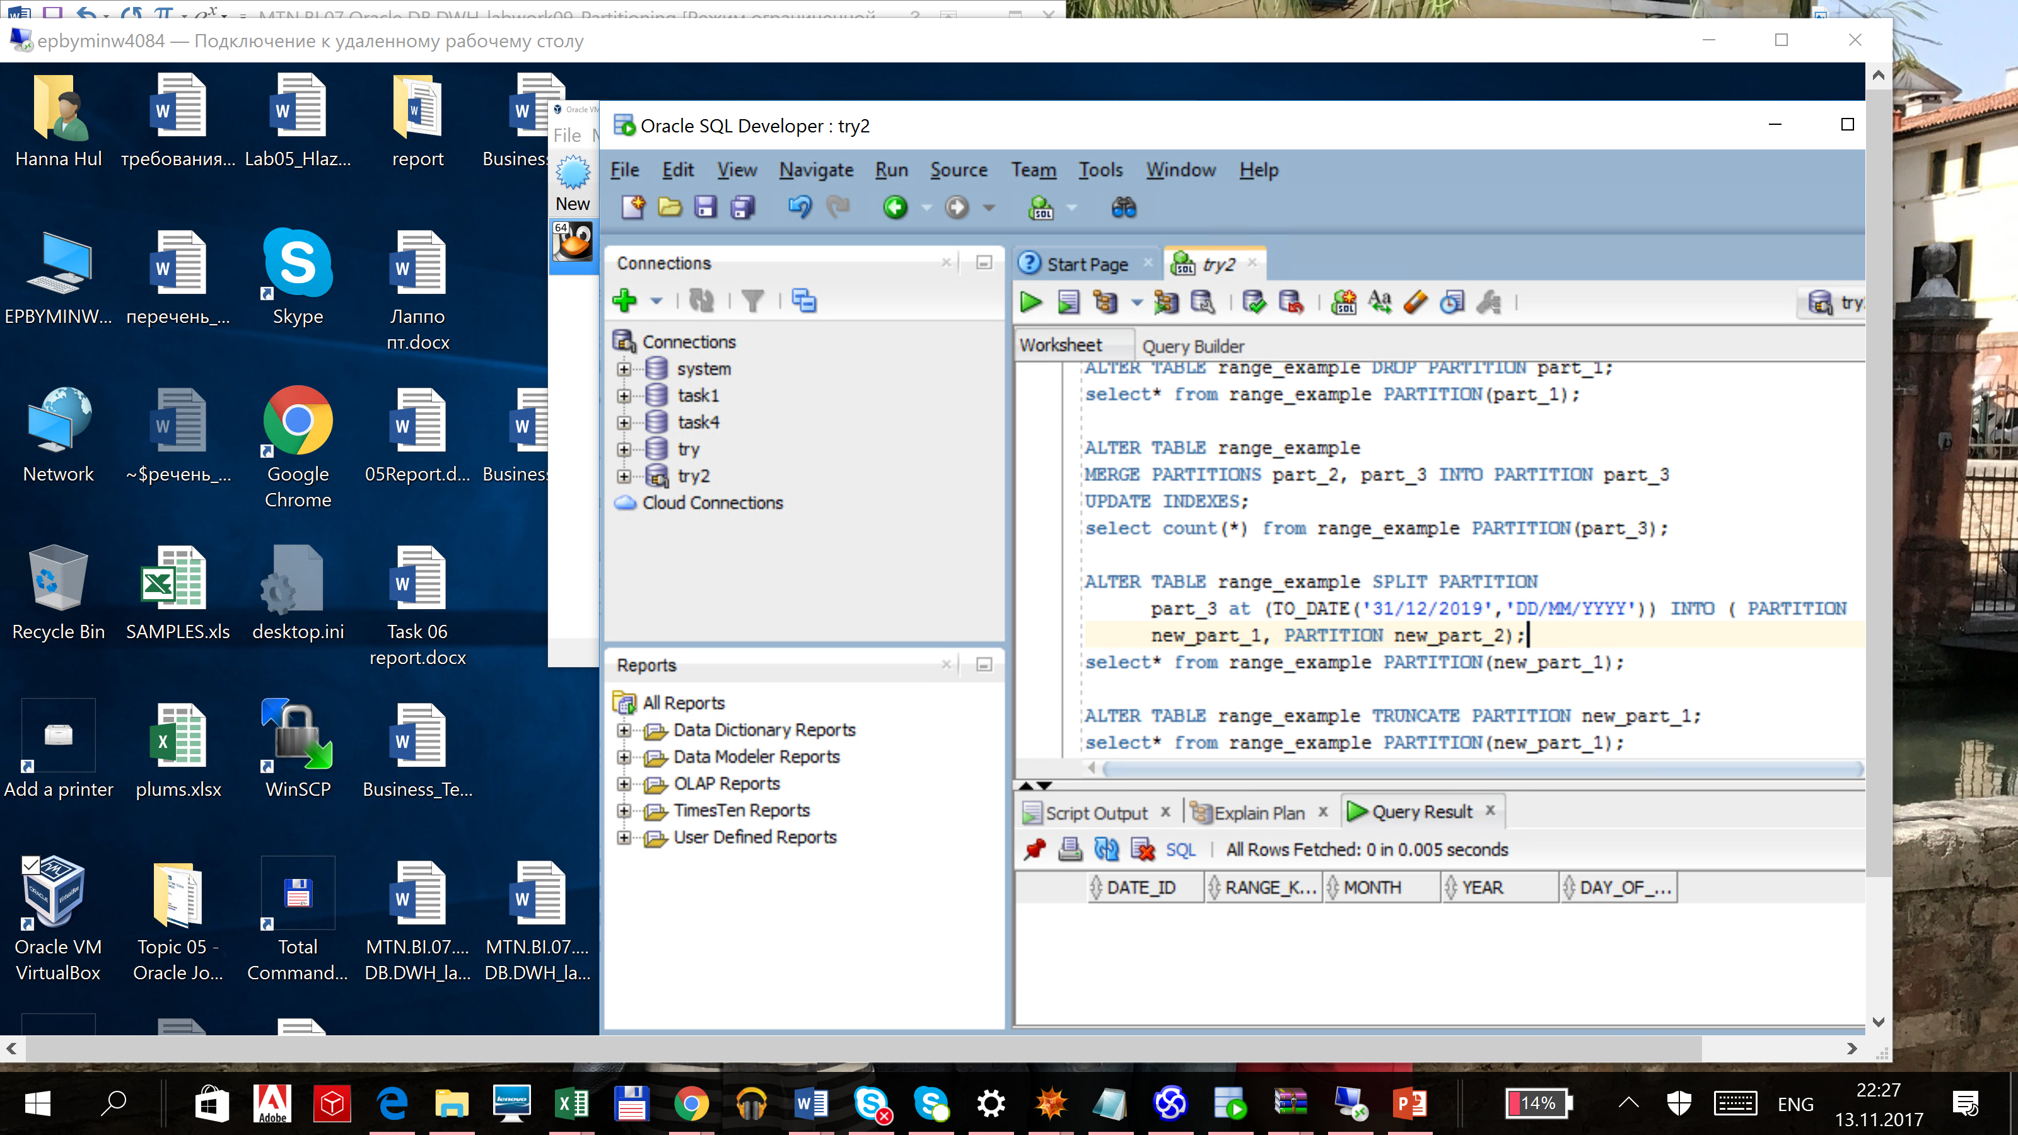

Let’s create Hash partitions and fill the table.

CREATE TABLE date_hash

(

key_column DATE NOT NULL,

MONTH VARCHAR2(20),

YEAR NUMBER

)

PARTITION BY HASH

(key_column)

(

PARTITION part_1,

PARTITION part_2,

PARTITION part_3

);

INSERT INTO date_hash

(

key_column,

MONTH ,

YEAR

)

SELECT

TO_DATE(CurrDate),

TO_CHAR(CurrDate,'Month'),

TO_CHAR(CurrDate,'YYYY')

FROM

(

SELECT level n,

TO_DATE('31/12/2016','DD/MM/YYYY') + NUMTODSINTERVAL(level,'day') CurrDate

FROM dual CONNECT BY level <= 1000

)

ORDER BY CurrDate;

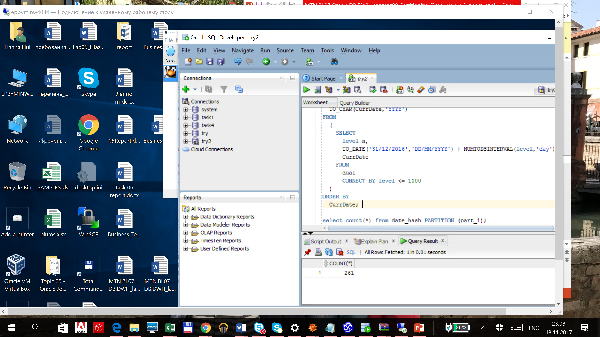**CHECKING**

* Coalescing Partition.

ENABLE ONLY IN HASH PARTITIONS

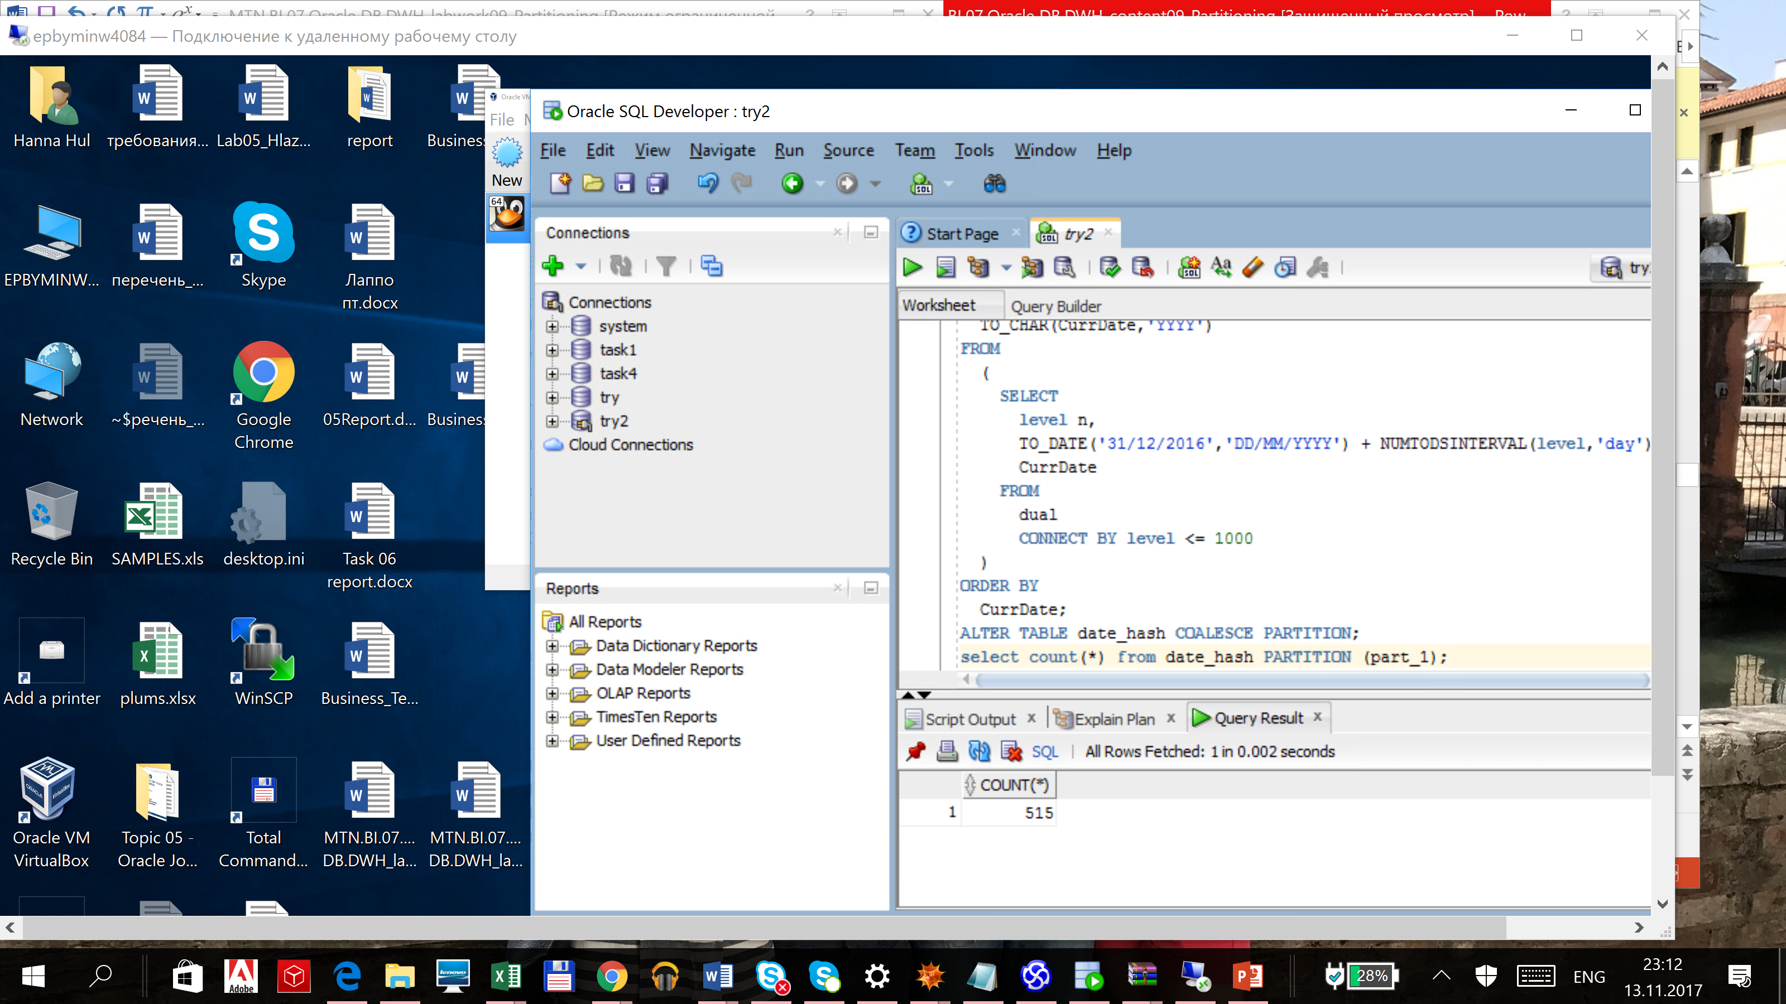ALTER TABLE date_hash COALESCE PARTITION;

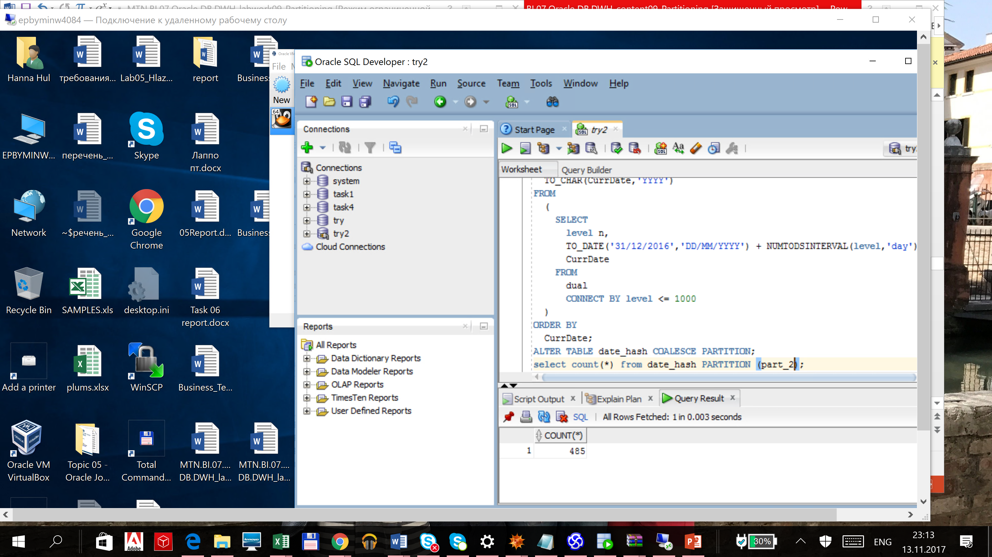

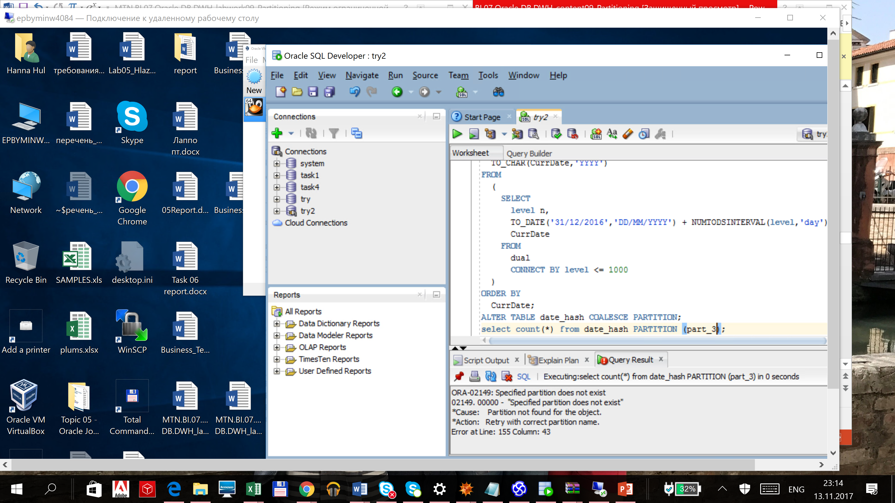

Partition 3 is not exist anymore, so the first and second partitions were rebuilt and became larger as expected.

* Moving Partition.

ENABLE ONLY IN HASH PARTITION.

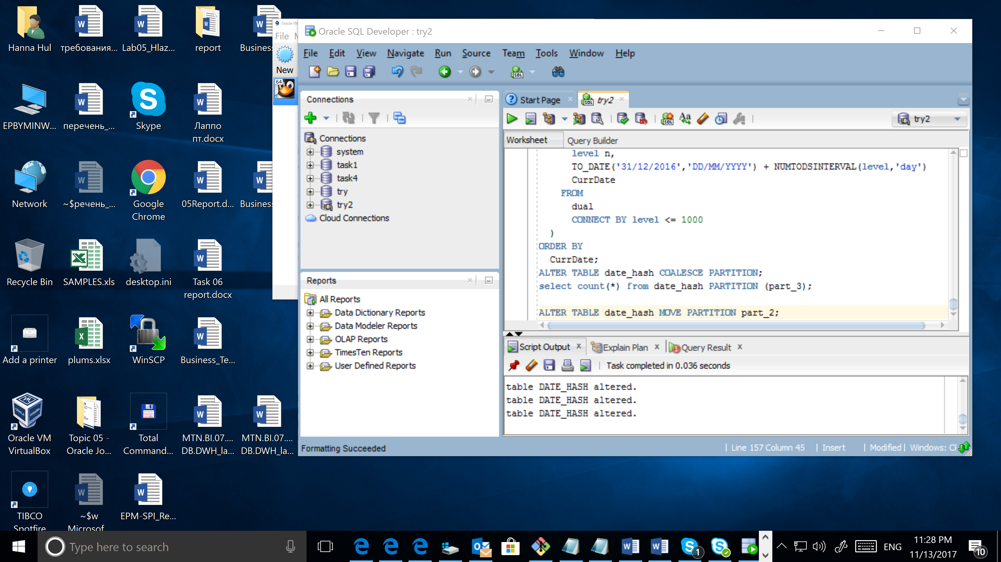

This statement always drops the old partition segment and creates a new segment, even if you do not specify a new tablespace.

# Analytical task

## Partitioning

Add chapter on describing Fact table partitioning strategy, which fields will it be based on and why (use composite partitioning).

I am still not sure about the data, so I could say only few words about partitioning. Fact table will have partitioning on order_date_id. All data will be divided by year in order_date_id. I think, that range partitioning will be a good decision here.

## Business

Create a report layout of the task you are trying to solve with your DWH (e.g. 'I want to analyze my sales on month and customers' region location and product type'). It could be done in Excel (just some headers, colors, dummy numbers, and little description) or any other tool of your preference. This would help to understand what task we are trying to solve.

# Results

Result of this lab work should be:

* Screenshots and description of partitioning maintenance operations.
* Chapter in document about advantages of partitioning the fact table in described way.
* Chapter in a document describing needed reports with possible layouts.